Template by: OWASP

# Threat Model Info

**Application Name:** Wellness Quest

**Application Version:** 0.1

**Description:**

**Document Owner: Lane Wilson**

**Participants:**

**Reviewer:**

# External Dependencies

| **ID** | **Description** |
| --- | --- |
| 1 | The application will be run on a user's device. |
| 2 | The connection between the user’s device and the server will be over a public connection. |
| 3 | The database will be SQL and will run on the same server as the backend application. |
|  |  |

# Entry Points

| **ID** | **Name** | **Description** | **Trust Levels** |
| --- | --- | --- | --- |
| 1 | Service Port | The backend will have a service port open to communicate with the user’s device. | (1) Unauthorized User  (2) Authorized User  (3) System Admin |
| 1.1 | Login Page | The application will have a login page for the users to enter into their accounts. | (1) Unauthorized User |
| 1.2 | Registration Page | The application will have a login page for the users to register for accounts. | (1) Unauthorized User |
| 1.3 | My-Challenges page |  |  |
| 1.3.1 | Manual data entry in app | The application will facilitate the user’s entering their workout data manually. | (2) Authorized User |
|  |  |  |  |

# Exit Points

| **ID** | **Name** | **Description** | **Trust Levels** |
| --- | --- | --- | --- |
| 1 | User Dashboard | The user has a dashboard that displays user first name. | (2) Authorized User |
|  |  |  |  |
|  |  |  |  |
|  |  |  |  |

# Assets

| **ID** | **Name** | **Description** | **Trust Levels** |
| --- | --- | --- | --- |
| 1 | User Login | The login details for the user will be stored | (1) Unauthorized User |
| 2 | User Workout Data | The workout data for the user will be stored | (2) Authorized User |
| 3 | User Challenge Data | The challenges the user has started and finished will be stored | (2) Authorized User |
| 4 | User Location Data | The data for the location of the user is temporarily stored for processing user progress | (3) System Admin |

# Trust Levels

| **ID** | **Name** | **Description** |
| --- | --- | --- |
| 1 | Unauthorized User | The user before being authorized with the login page |
| 2 | Authorized User | The user after being authorized with the login page |
| 3 | System Admin | The person with admin access to the server |
|  |  |  |

# Data Flow Diagrams

Currently, the Registration and Login pages are focused due to their importance in modifying database data.

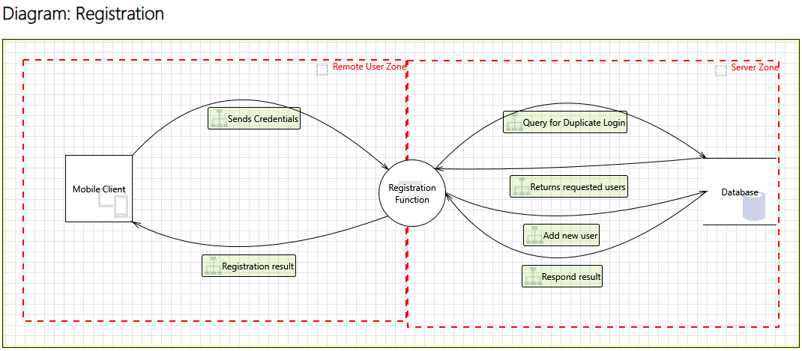

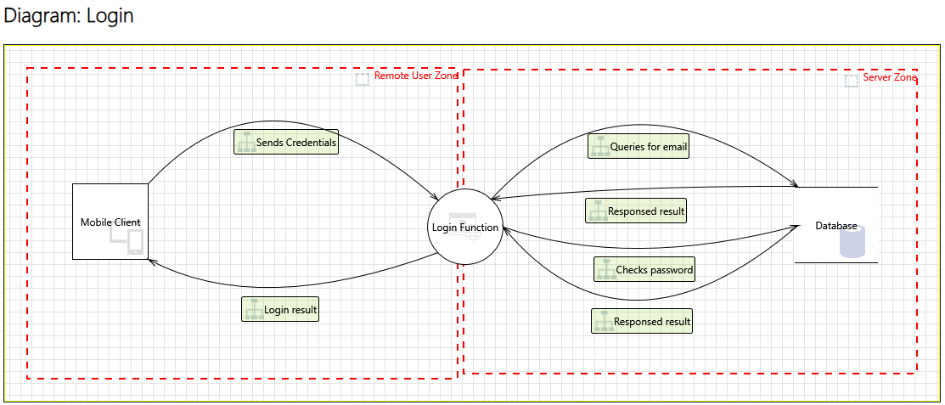

# See Threat Report Page for Mitigated Threats